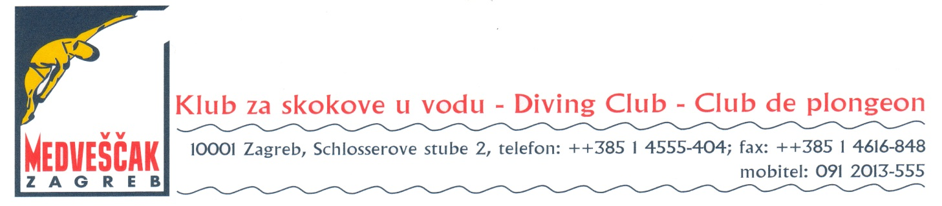

17th Easter Zagreb diving meeting, 5th Stjepan Križić Memorial
7.-9. April 2017.

Preliminary Entry form

Federation / Club:
Adress:
Telephone, e-mail:

Number of Female divers
Number of Male divers
Number of Official (Coaches,etc,..)
Total number of Persons

Date Signature

Please complite and return to: sanda.donoval@gmail.com, diving.zagreb@gmail.com
This Preliminary Entry Form must be received
not later than 20th February 2017

