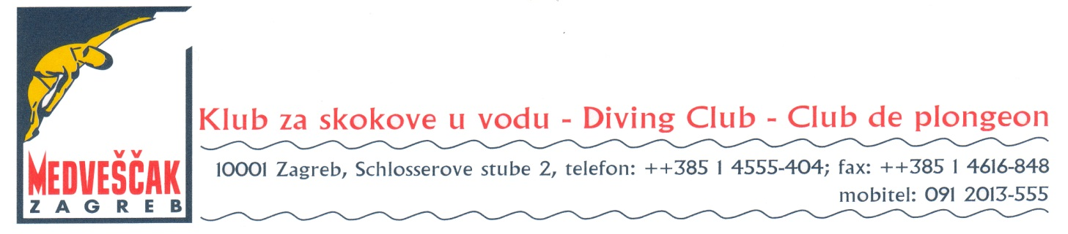

15th Easter Zagreb diving meeting, 4th Stjepan Križić Memorial
27.-29. March 2015

Preliminary Reservation form

Federation / Club:
Adress:
Telephone, e-mail:

Travel schedule: day of arrival
day of departure
by car by Train by Plane
Acomondation: Hotel Panorama
Number of single room:
Number of double room:
Number of 3 bed room:
Number of 4 bed room:

Date Signature

Please complite and return to diving.zagreb@gmail.com
This Preliminary Entry Form must be received not later than
5th February 2015

